

**School Management System**

**Project Submitted As Per The Requirement of CBSE (2020-2021) Practical of Computer Science.**

Name:- GAGAN CHAUHAN

Class:- XII ‘E’

Roll No.:- 14 Board Roll No.:25636421

Submitted To:- Mr. Vivek Dalakoti

School:- Jaycees Public School

**Certificate**

Roll No:14 Exam No:25636421

This is to certify that GAGAN CHAUHAN student of class 12th has successfully completed the research on the below mentioned project under the guidance of Mr. VIVEK DALAKOTI during the year of 2020-21 partial fulfillment of computer science practical examination conducted by CBSE.

TEACHER’ SIGNATURE:

PRINCIPAL SIR SIGNATURE:

EXAMINER SIGNATURE:

**Acknowledgement**

In the accomplishment of this project successfully, many people have best owned upon me their blessings and the heart pledge support, this time I am utilizing to thank all the people who have been concerned with this project. Primarily I would like thank god for being able to complete this project with success. Then I would like to My Computer science teacher Mr. Vivek dalakoti whose valuable guidance has been the ones that helped me patch this project and make it full proof success, his suggestions and instruction has served as the major contribution towards the completion of this project.

Then I would like to thank my parents who have helped me with their valuable suggestions and guidance has been very helpful in various phases of the completion of the project.

INDEX

|  |  |  |
| --- | --- | --- |
| SR.NO | CONTENT | PAGE NO |
| 1. | REQUIREMENT | 5 |
| 2. | INTRODUCTION | 6 |
| 3. | MODULES/FUNCTIONS  USED | 7 |
| 4. | CODE | 8 |
| 5. | SCREENSHOTS | 25 |
| 6. | LIMITATIONS | 32 |
| 7. | BIBLIOGRAPHY | 33 |

**REQUIREMENT**

**Minimum System Requirements:**

Processors: Intel i3 processor.

Disk space: 2 to 4 GB.

Operating systems: Windows 7 OR Above.

Python Versions: 3.7 or Higher.

**Prerequisites before installing MySQL Connector Python**

You need root or administrator privileges to perform the installation process. Python must be installed on your machine.

Note: – MySQL Connector Python requires python to be in the system’s PATH. Installation fails if it doesn’t find Python. On Windows, If Python doesn’t exist in the system’s PATH, please manually add the directory containing python.exe yourself.

**INTRODUCTION**

School management system project in python with mysql connectivity is a simple console application built without the use of graphics. This project school management system helps in managing the record of students and teachers according to their roll no and Acno. In this project we tried to enter all details of students like roll no, name, class etc. and tried to maintain all the possibility which may help the user to enter more record if he/she requires. Some of the features of the program are:

1. ADD STUDENT 7. SUBMIT FEES

2. REMOVE STUDENT 8. PAY SALARY

3. ADD TEACHER 9. dISPLAY CLASS

4. REMOVE TEACHER 10. TEACHER LIST

5. CLASS Attendence(ADD ABSENT STUDENTS)

6. TEACHER Attendence(ADD ABSENT TEACHERS)**Modules/Functions used in Project:**

* **Import mysql.connector**:- Module used to connect Python with MySQL.
* **Fetchall()**: to fetch records from a result set.
* **deaf()**: FUNCTION FOR CREATING DEAFULT STUDENTS TABLE.
* **ast()**: FUNCTION TO STORE STUDENT DETAILS
* **rst():** FUNCTION TO REMOVE STUDENT
* **addt():** FUNCTION TO ADD TEACHER
* **remt():** FUNCTION TO REMOVE TEACHER
* **abclass():** FUNCTION TO STORE ABSENT STUDENT NAME
* **abteacher():** FUNCTION TO STORE ABSENT TEACHER NAME
* **submitf():** FUNCTION TO STORE FEES OF STUDENT
* **pays():** FUNCTION TO STORE SALARY DETAILS
* **dclass():** FUNCTION TO DISPLAY STUDENTS
* **dteacher():** FUNCTION TO DISPLAY TEACHER SOURCE CODE

#***********************************************************

**# SCHOOL Management System**

#***********************************************************

#***********************************************************

import mysql.connector as a

con=a.connect(host="localhost",user="root",passwd="1234",)

c=con.cursor()

**# TO BE RUN ONLY ONCE**

#***************************************************************

**# Creating DATABASE/TABLES USED IN PROJECT**

#***********************************************************

c.execute("create database school")

c.execute("use school")

c.execute("create table student(name char(30),class int,roll_no int,address char(50),phone int)")

c.execute("create table teacher(name char(30),post char(30),salary int,address char(220),phone int,acno int)")

c.execute("create table cattendence(year int,month char(30),date varchar(30),class varchar(30),absent varchar(220))")

c.execute("create table tattendence(year int,month char(30),date varchar(30),absent varchar(220))")

c.execute("create table fees(name char(30),class int,roll_no int,Month varchar(22),fees int,date int)")

c.execute("create table salary(name char(30),month varchar(30),paid varchar(234))")

**# CREATING DEAFULT TABLE**

def deaf():

c=con.cursor()

c.execute("create table deafaultstudent(name char(30),class varchar(30),roll_no int,address varchar(220),phone int)")

c.execute("insert into deafaultstudent(name,class,roll_no,address,phone) values('{}',{},{},'{}',{})".format('raj kapoor',12,10,'rdr',233455))

c.execute("insert into deafaultstudent(name,class,roll_no,address,phone) values('{}',{},{},'{}',{})".format('jatin kalra',12,1,'dineshpur',238655))

c.execute("select*from deafaultstudent")

print("select from this table any student you want to remove")

for i in c:

print(i)

l=int(input("class :"))

r=int(input("Roll no:"))

k="delete from deafaultstudent where roll_no={} and class={}".format(r,l)

c.execute(k)

con.commit()

print("STUDENT DETAILS DELETED SUCESSFULLY")

print(">-------------------------<")

main()

**# TO STORE STUDENT DEATILS**

def ast():

n=int(input("class:"))

m=input("names:")

p=int(input("enter roll:"))

ph=int(input("enter phone:"))

d=input("enter address:")

k="insert into student(class,roll_no,phone,name,address) values({},{},{},'{}','{}')".format(n,p,ph,m,d)

c=con.cursor()

c.execute(k)

con.commit()

print("STUDENT ADDED sucessfully")

print(">-------------------------<")

main()

**# TO REMOVE STUDENT**

def rst():

c=con.cursor()

z="select*from student"

c.execute(z)

for i in c:

print(i)

l=int(input("Class:"))

r=int(input("Roll no:"))

c=con.cursor()

k="delete from student where roll_no={} and class={}".format(r,l)

c.execute(k)

con.commit()

print("STUDENT DELETED SUCCESSFULLY.")

print(">-------------------------<")

main()

**# TO ADD TEACHER**

def addt():

n=input("teacher name:")

c=input("post:")

r=int(input("Salary:"))

a=input("address:")

p=int(input("phone:"))

m=int(input("Account no:"))

k="insert into teacher(name,post,salary,address,phone,acno) values('{}','{}',{},'{}',{},{})".format(n,c,r,a,p,m)

c=con.cursor()

c.execute(k)

con.commit()

print("TEACHER ADDED sucesssfully")

print(">-------------------------<")

main()

**#TO REMOVE TEACHER**

def remt():

c=con.cursor()

z="select*from teacher"

c.execute(z)

for i in c:

print(i)

m=input("name:")

r=int(input("Ac no. :"))

c=con.cursor()

k="delete from teacher where acno={}".format(r)

c.execute(k)

con.commit()

print("TEACHER REMOVED")

print(">-------------------------<")

main()

**#TO STORE ABSENT STUDENT NAME**

def abclass():

y=int(input("year:"))

m=input("month:")

d=eval(input("date:"))

cl=int(input("class:"))

ab=input("name of absent students:")

sql="insert into cattendence values({},'{}','{}',{},'{}')".format(y,m,d,cl,ab)

c=con.cursor()

c.execute(sql)

con.commit()

print("ABSENT STUDENT ADDED SUCCESSFULLY.")

print(">-------------------------<")

main()

**#TO STORE ABSENT TEACHER NAME**

def abteacher():

y=int(input("year:"))

m=input("month:")

d=int(input("date:"))

ab=input("name of absent Teacher:")

sql="insert into tattendence values({},'{}','{}','{}')".format(y,m,d,ab)

c=con.cursor()

c.execute(sql)

con.commit()

print("ABSENT TEACHER ADDED SUCCESSFULLY.")

print(">-------------------------<")

main()

**# TO STORE FEES OF STUDENT**

def submitf():

n=input("student name:")

c=int(input("class :"))

r=input("Roll no:")

m=input("month")

f=int(input("fees:"))

d=int(input("date:"))

sql="insert into fees values('{}',{},'{}','{}',{},{})".format(n,c,r,m,f,d)

c=con.cursor()

c.execute(sql)

con.commit()

print("FEES SUBMITTED sucesssfully")

print(">-------------------------<")

main()

**# TO STORE SALARY DEATILS**

def pays():

n=input("teacher name:")

m=input("Month:")

p=input("PAID Yes/No:")

sql="insert into salary values('{}','{}','{}')".format(n,m,p)

c=con.cursor()

c.execute(sql)

con.commit()

print("data entered sucesssfully")

print(">-------------------------<")

main()

**# TO DISPLAY STUDENTS**

def dclass():

sql="select*from student "

c=con.cursor()

c.execute(sql)

d=c.fetchall()

for i in d:

print("NAME:",i[0])

print("CLASS:",i[1])

print("ROLL NO:",i[2])

print("ADDRESS:",i[3])

print("PHONE:",i[4])

print(">-------<")

print(">-------------------------<")

main()

**# TO DISPLAY TEACHER**

def dteacher():

sql="select*from teacher"

c=con.cursor()

c.execute(sql)

d=c.fetchall()

for i in d:

print("NAME:",i[0])

print("POST",i[1])

print("SALARY:",i[2])

print("ADDRESS:",i[3])

print("PHONE:",i[4])

print("ACNO:",i[5])

print(">-------<")

print(">-------------------------<")

main()

#\*\*\*\*\*\*\*\*\*\*\*\*\*\*\*\*\*\*\*\*\*\*\*\*\*\*\*\*\*\*\*\*\*\*\*\*\*\*\*\*\*\*\*\*\*\*\*\*\*\*\*\*\*\*\*\*\*\*\***#THE MAIN FUNCTION OF PROGRAM**

#***********************************************************#The Main()

def main():

print(""" JAYCEES PUBLIC SCHOOL

1. ADD STUDENT 2. REMOVE STUDENT

3. ADD TEACHER 4. REMOVE TEACHER

5. CLASS Attendence(ADD ABSENT STUDENTS)

6. TEACHER Attendence(ADD ABSENT TEACHERS)

7. SUBMIT FEES 8. PAY SALARY

9. dISPLAY CLASS 10. TEACHER LIST

*for removing/displaying teacher first Add Teacher(use "3")*

# TO BE RUN ONLY ONCE

""")

Choice=input("ENTER TASK NO:")

if (Choice=="1"):

ast()

elif (Choice=="2"):

n=input("you want to remove student from 'default stored table' or table you have 'created now' ??? enter 'd' for default or 'c' for created now: ")

if n=="c":

rst()

else:

deaf()

elif (Choice=="3"):

addt()

elif (Choice=="4"):

remt()

elif (Choice=="5"):

abclass()

elif (Choice=="6"):

abteacher()

elif (Choice=="7"):

submitf()

elif (Choice=="8"):

pays()

elif (Choice=="9"):

dclass()

elif (Choice=="10"):

dteacher()

else:

print("WRONG CHOICE!!!!!!!!")

main()

def pasd():

p=input("PASSWORD:")

print("use '1234' to access")

if p=="1234":

main()

else:

print("access denied!")

print("Enter again:")

pasd()

pasd()

#***************************************************

#**************** **END OF PROJECT** ***************

#***************************************************

**OUTPUT(SCREENSHOTS)**

1. **MAIN SCREEN**

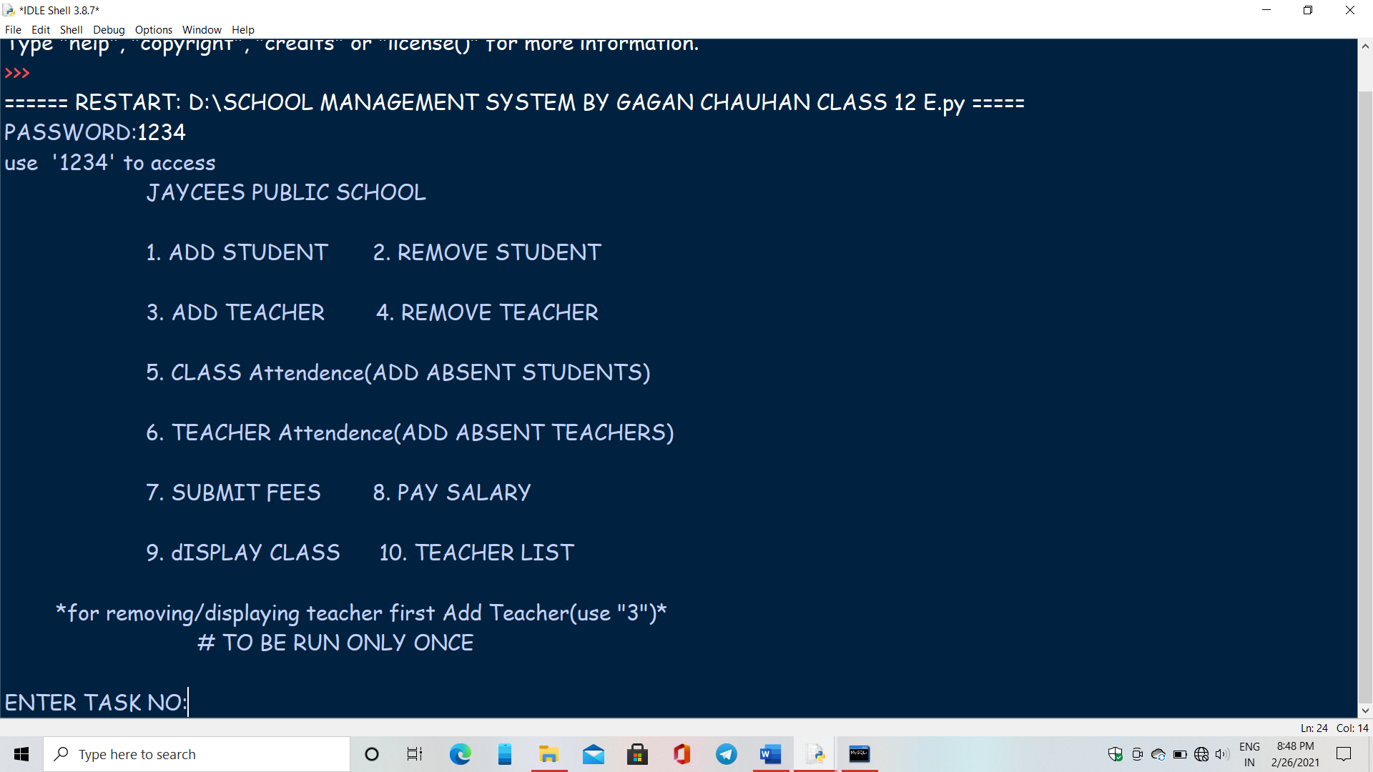

**2.ADDING STUDENT DETAILS**  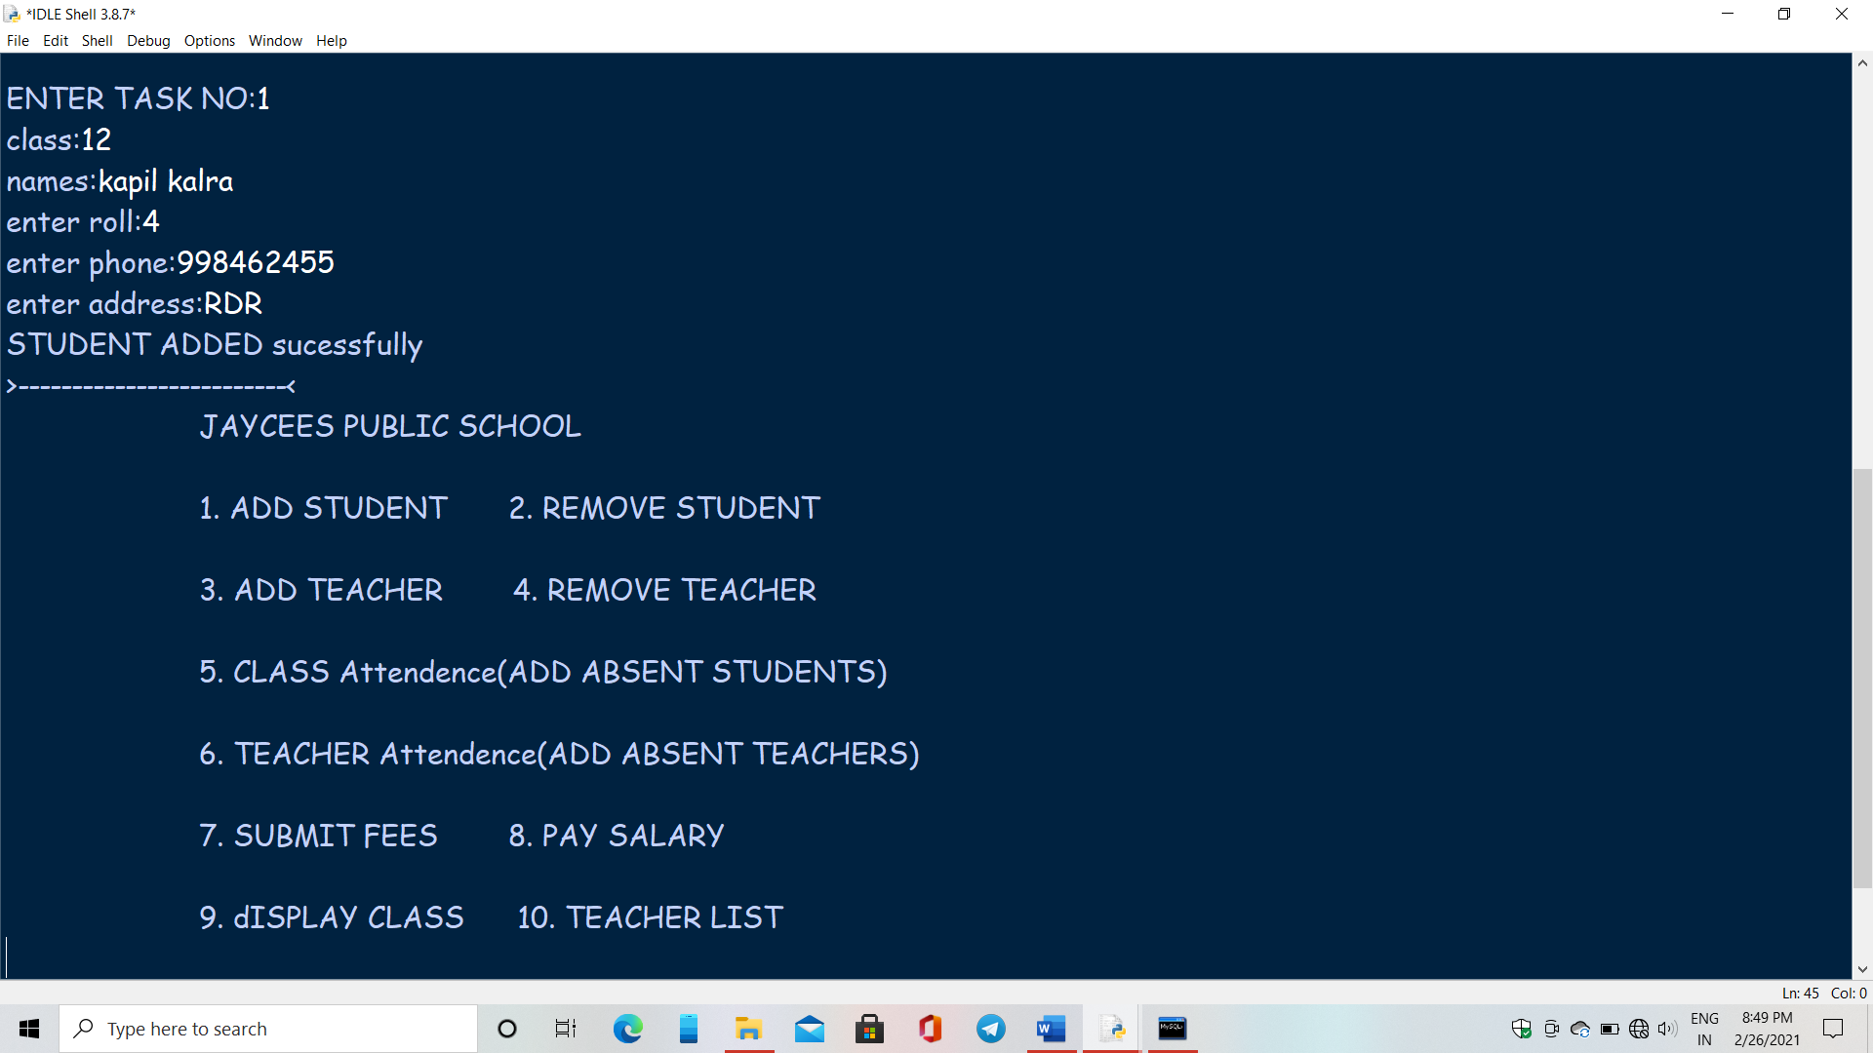

3.**REMOVING STUDENT**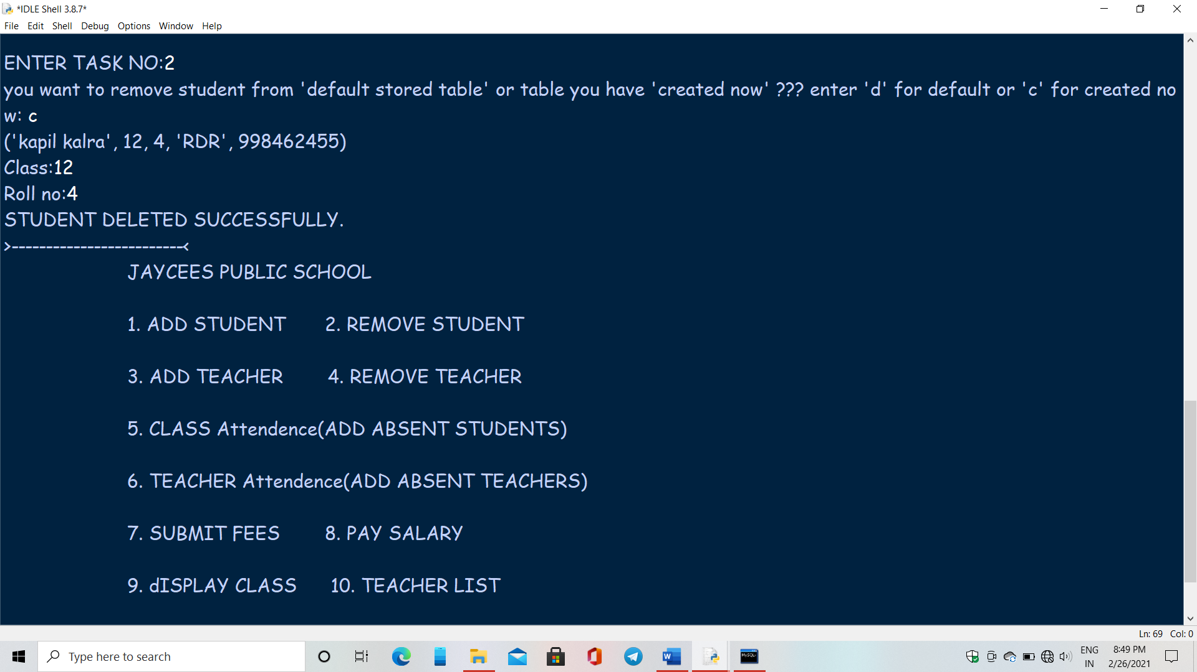

**4.REMOVING STUDENT(DEFAULT STUDENTS)**

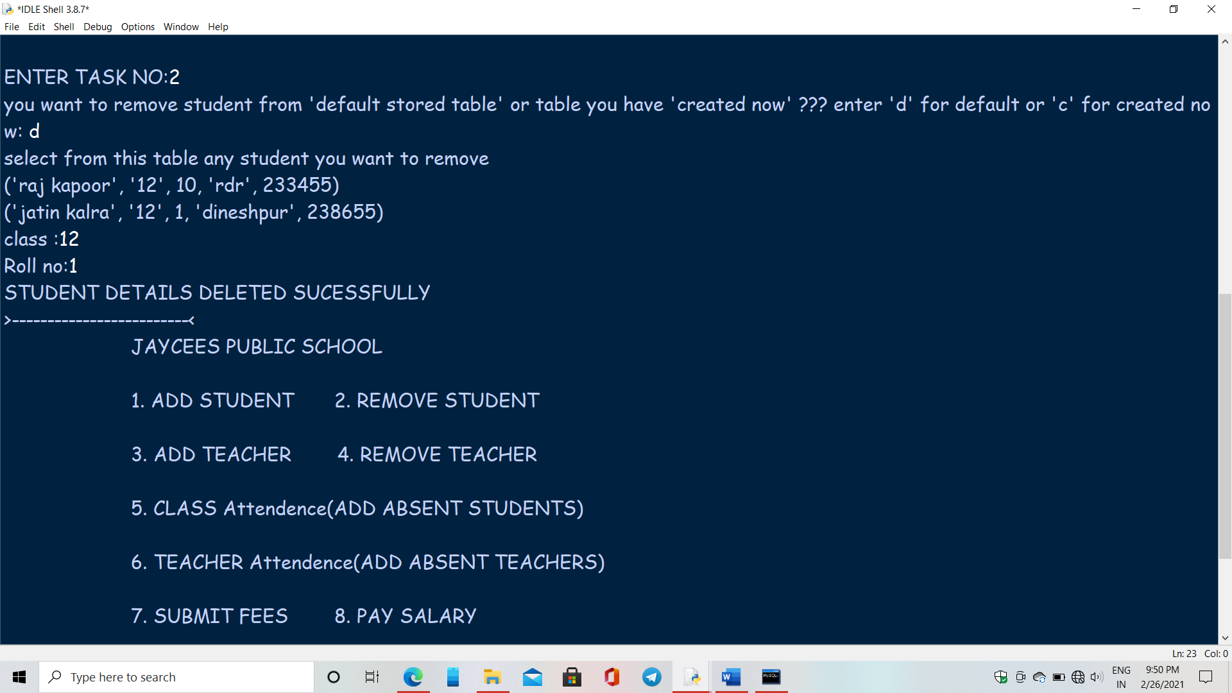

**5.ADDIND NEW TEACHER DETAILS** 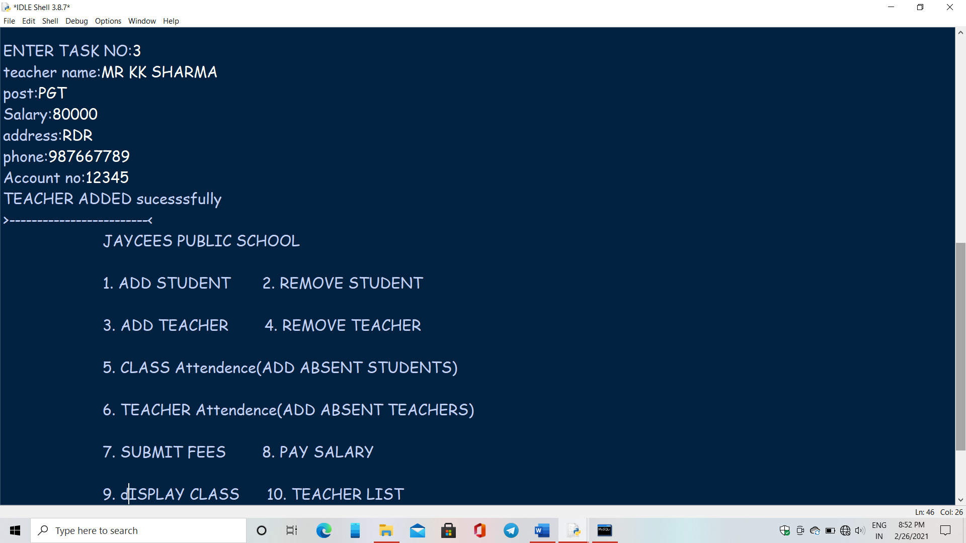

**6.REMOVING TEACHER DETAILS**

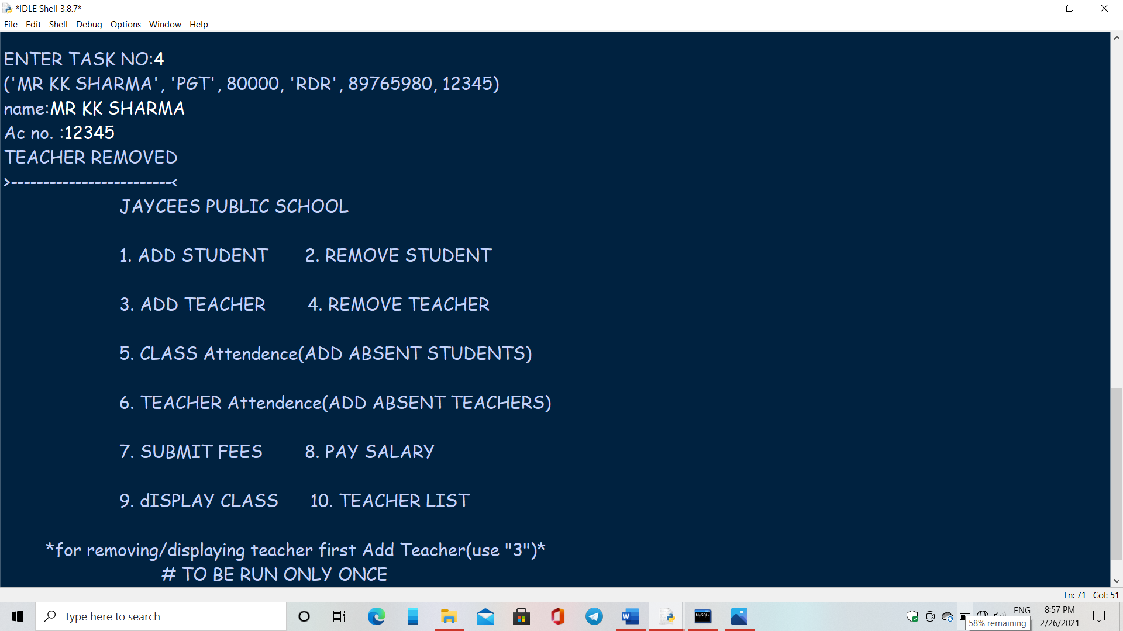

**7.ADDING ABSENT STUDENT NAMES**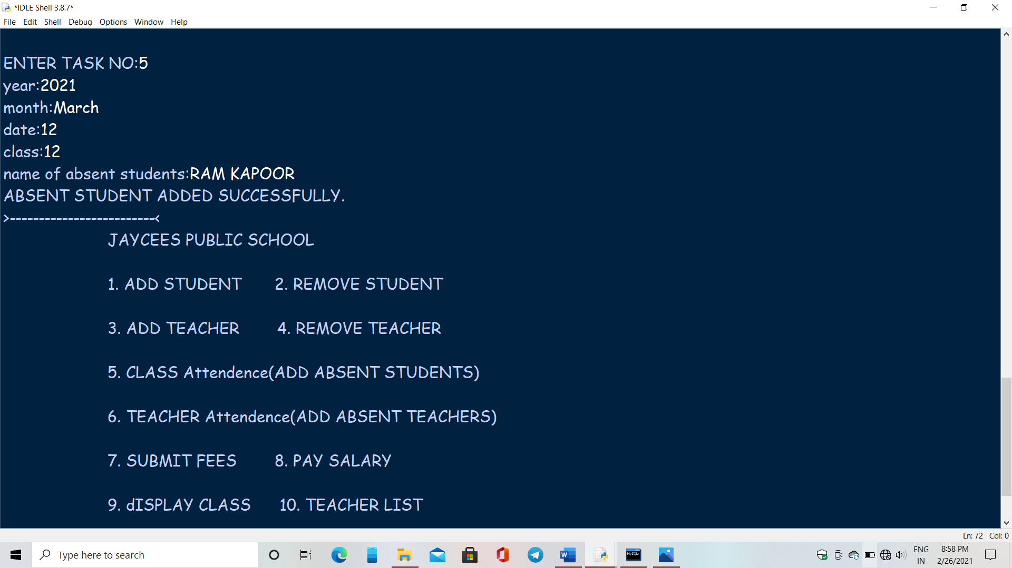

**8.ADDING ABSENT TEACHER**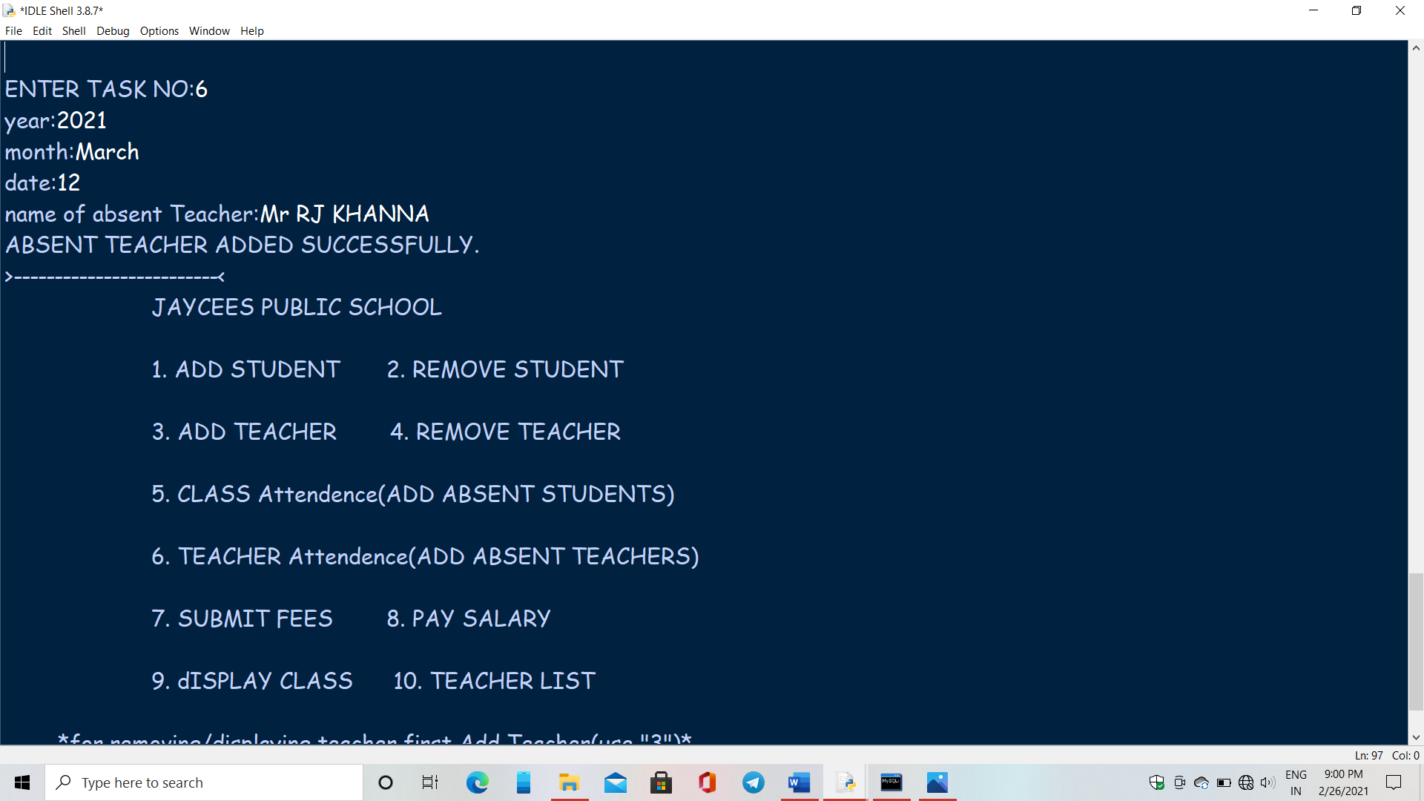

**9.SUBMITTING STUDENTS FEES**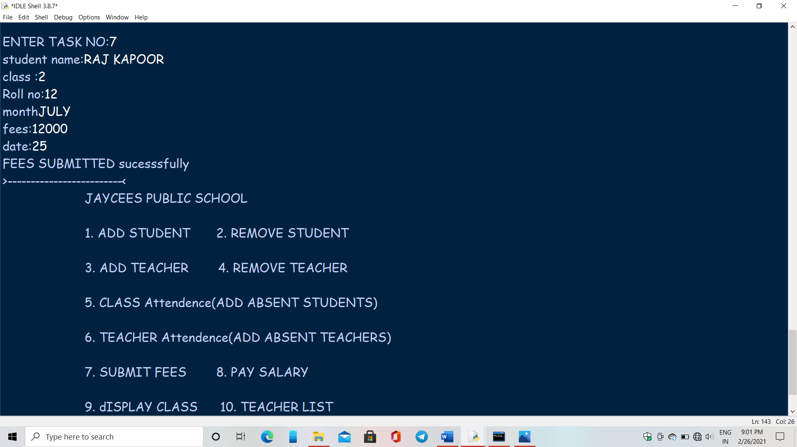

**10.PAYING SALARY TO TEACHER**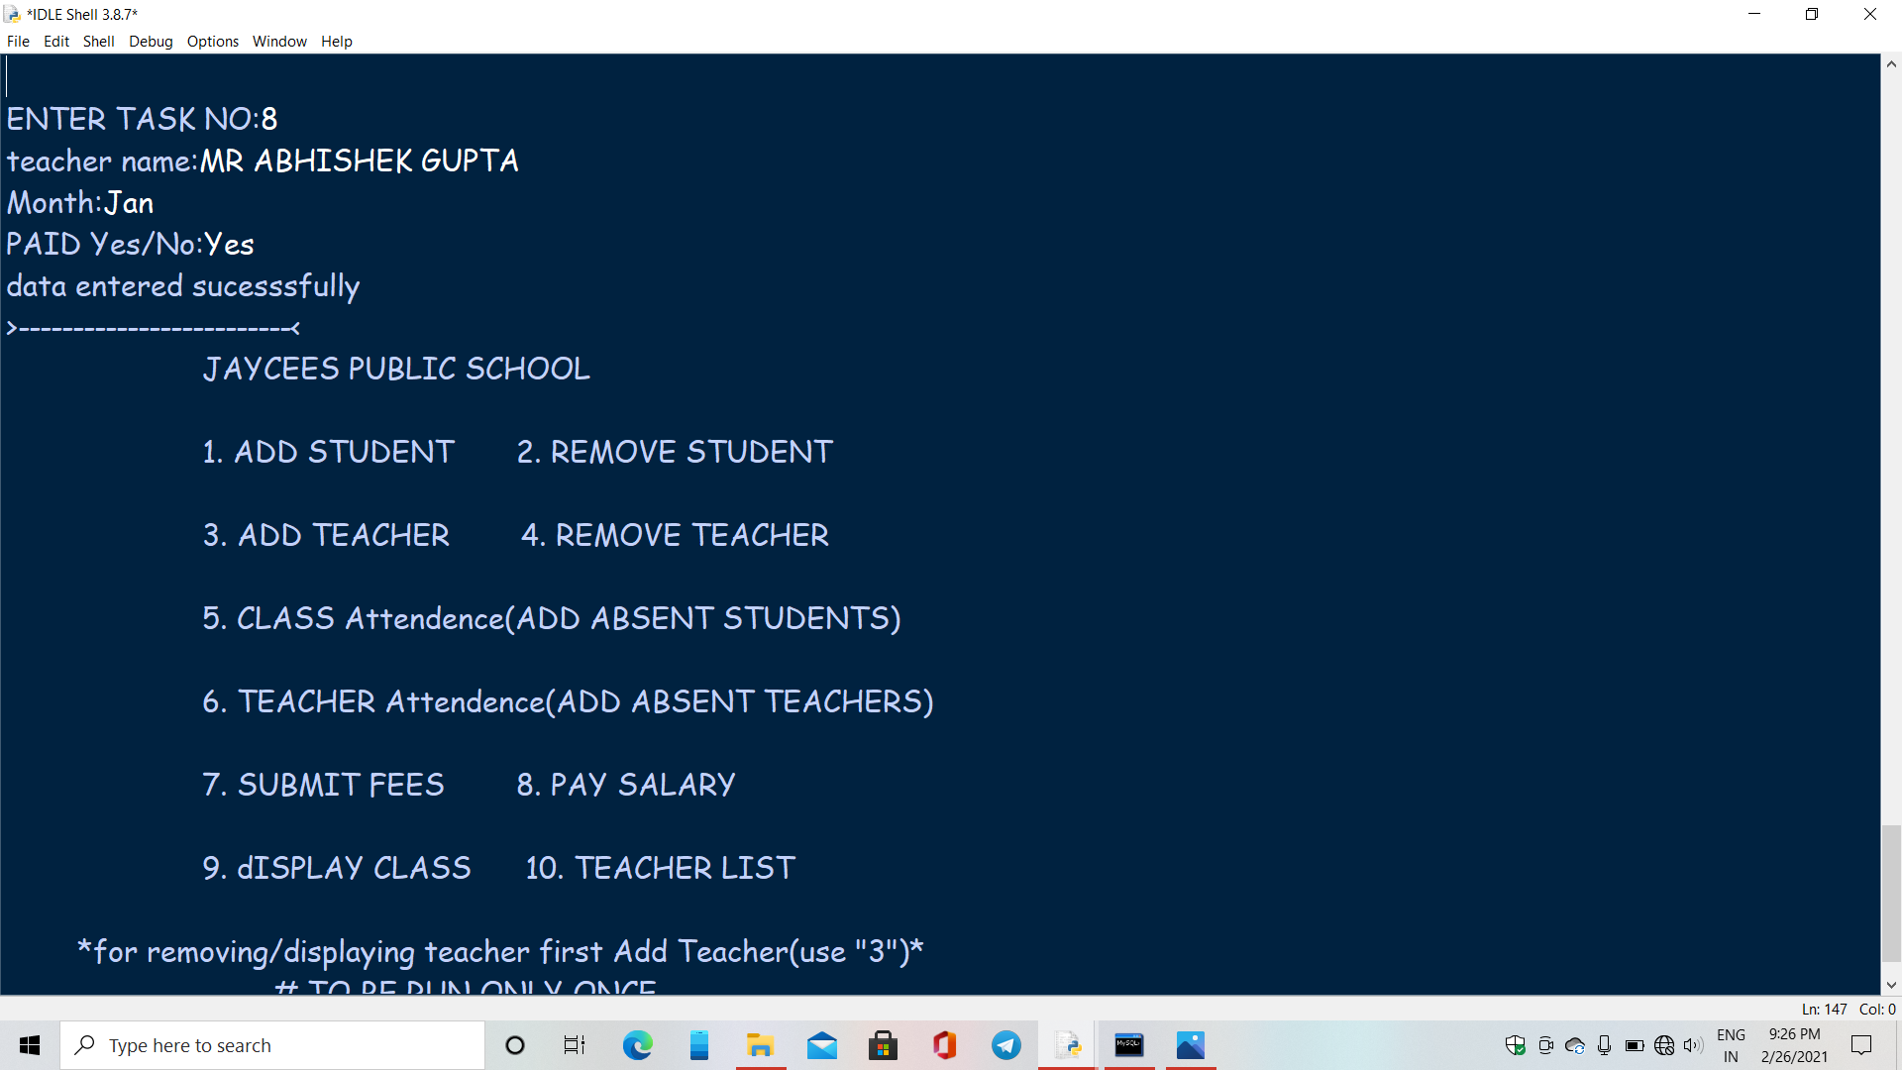

**11.DISPLAYING CLASS**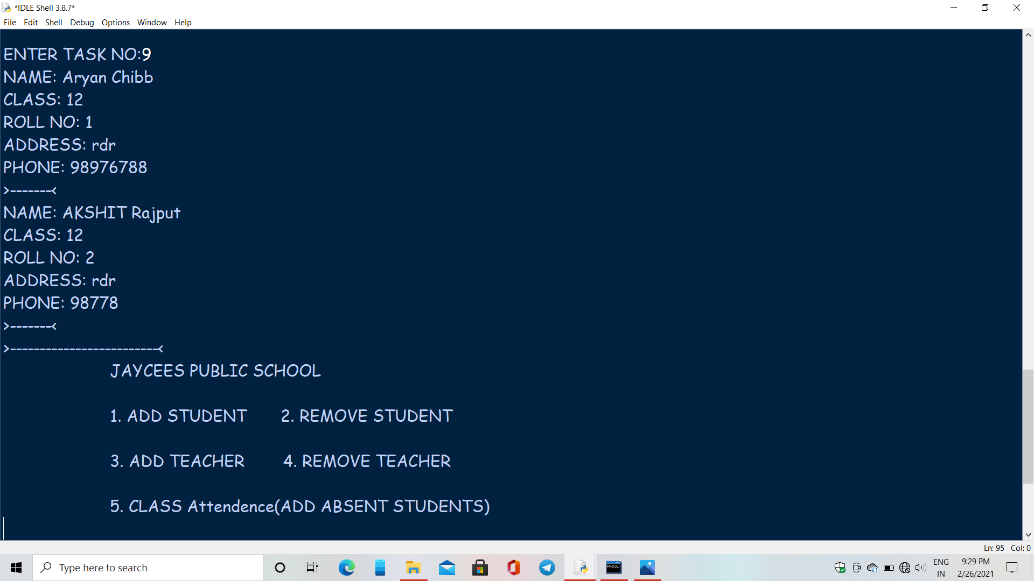

**12.DISPLAYING TEACHERS**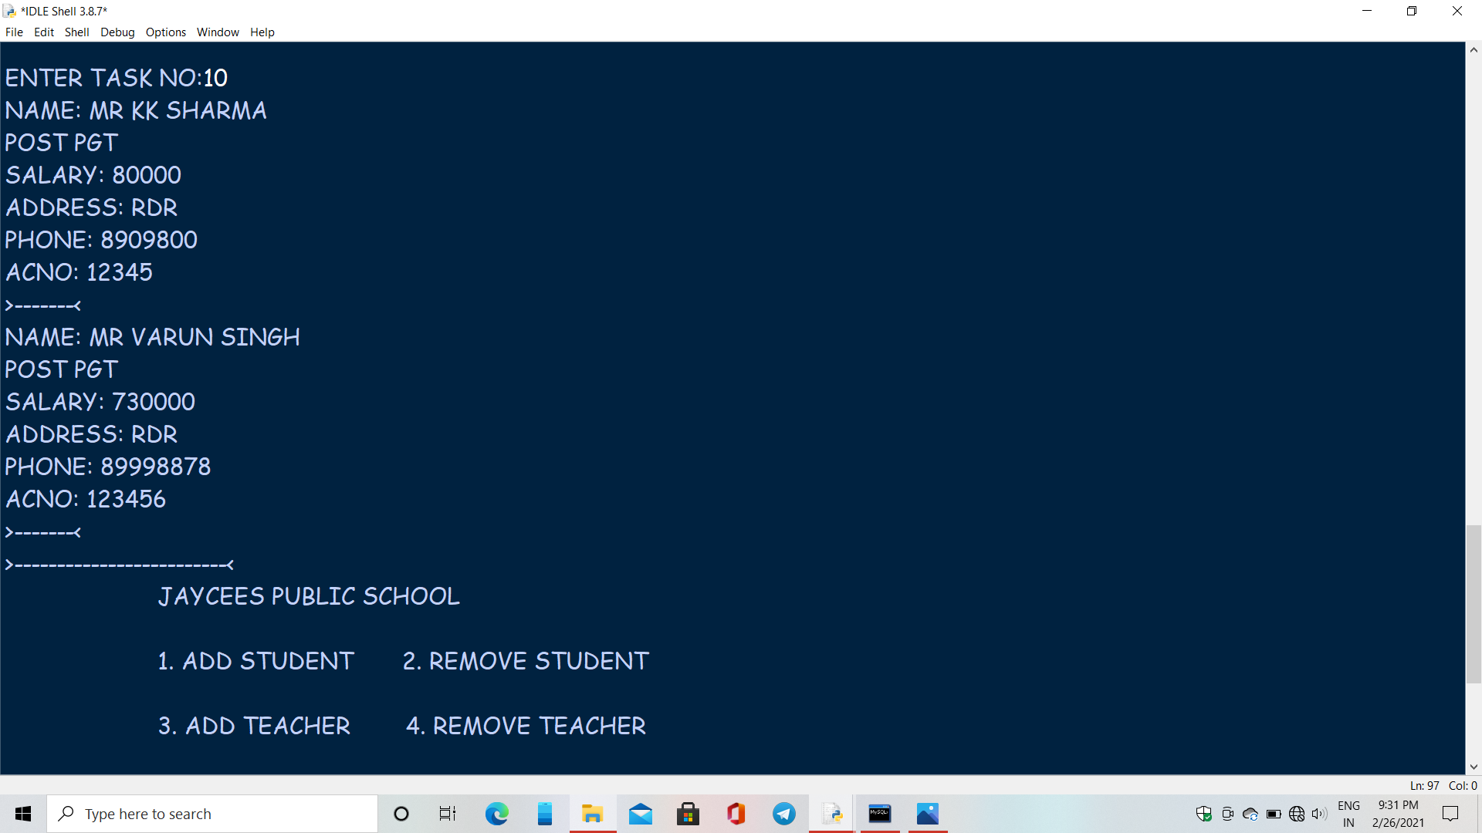

LIMITATION

* Does not support mouse.
* If some string is gives as input i.e. in place where integer should have been input, the program crashes and data file gets spoiled.
* Can only be Runed once.
* To remove teacher you need to add teacher details first.

Bibliography

* Sumita arora class 12
* Website:

<http://www.google.co.in>

http://www.wikipedia.com

THANK

YOU